JNDS-***50
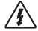 | Warning: Indicates have potentially dangerous, take extra care when performing this task.
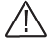 | Warning: Indicates the controller safe and correct operation of a key program.
 | Note: this step or fuction is very important for the controller's safe and proper operation
——New type of solar power controller

Regular technical parameters
Rated system voltage ____VDC
Rated charge current 50A
Rated discharge current NO
Photovoltaic maximum input voltage① ____VDC
Photovoltaic maximum input power ____W
①Maximum input voltage, is refers to the applications at the lowest temperature under the condition of photovoltaic modules of open circuit voltage (VOC), namely the VOC values should be less than or equal to the provisions of the photovoltaic maximum input voltage value.

I.Important Safety Information

Please keep this manual for later use.
This manual contains the JNDS solar controller all safety, installation and operating instructions.
Following icon manual runs through the whole manual, indicating an action may be potentially dangerous situation, or important safety operation steps, come across these ICONS, must pay attention to.
General Safety Information
·Prior to installation, please read all the instructions in the manual and matters needing attention.
·JNDS series controller, no need of maintenance or repair parts, users don't disassembly and maintenance the controller itself.
·Disconnect the solar module and fuse/breaker near to battery before installing or adjusting the controller.
·Install external fuses/breakers as required.
·Prevent any liquid from spattering on controller. Do not clean the controller with wet cloth.
·Confirm that power connections are tightened to avoid excessive heating from loose connection.
·Keep controller away from electrical heater, warmer and avoid controller under sunlight.

II.Basic information

2.1General Description
Thank you for choosing JXDS power station controller. My company production of a new generation of JNDS series controller is a according to the latest technology development, represents the latest photovoltaic technology development level of products, this product has many excellent performance:
·Excellent thermal design and air cooling control.
·High efficient PWM charging ways.
·Variety of load control method, enhanced the flexibility of the system
·Battery charging parameters can be set up.
·Any combination of photovoltaic module and storage battery reverse automatic protection function, no damage to any device.
·Adopt traditional LCD liquid crystal display and keyboard design, convenient to view the running parameters of the controller.
·Provide industrial generic RS232 communication interface, the user can design PC communication software, also can buy the company developed the upper machine communication accessories.

This controller used for off-grid solar power systems (independent system), especially suitable for small off-grid solar power control system, automatically adjust the charging and discharging.
JNDS series controller’s battery charging process is optimized, can prolong the life of battery, improve system performance.
Its comprehensive self-test function and electronic protection function can be avoided due to installation errors and damage of system failure caused the controller damaged.

2.2 LCD, LED, and buttons Description
Although JND - X series controller is easy to operate and use, in order to make you better able to use all functions of the controller, to improve your pv systems, would you please take a little time to get to know the instructions and instructions in this manual.
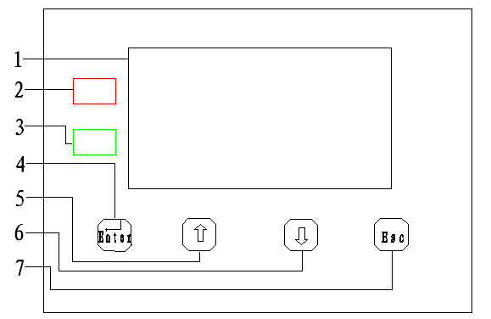
1 - LCD display
Display system operation parameters.
2 - Charge indicator
Indicate the charging status.
3 - Battery indicator light
Indicate the battery voltage and discharge state.
4 - Set the button
Press this button to enter setup interface or change the Settings.
5 -”↑” button
Click this button add a page up or figures.
6 - “↓” button
Press the page up or number minus one.
7 - Exit button
Under the set interface to browse interface, press this key to exit the setup interface does not save the Settings data when power supply drop.

2.3 Terminal Description
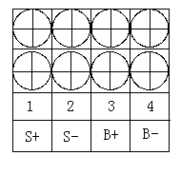
1 - solar panels NO.1 positive pole S+
2 - solar panels NO.1 negative pole S-
3 - Battery positive pole B+
4 - Battery negative pole B-

III.Installation instructions

3.1 Installation considerations

·Be very careful when working with batteries. Wear eye protection. Have fresh water available to wash and clean any contact with battery acid.
·Uses insulated tools and avoid placing metal objects near the batteries.
·Explosive battery gasses may be present during charging .Be certain there is sufficient ventilation to release the gasses.
·Avoid direct sunlight and do not install in locations where water can enter the controller.
· Loose power connections and /or corroded wires may result in resistive connections that melt wire insulation, burn surrounding materials, or even cause fire. Ensure tight connections and use cable clamps to secure cables and prevent them from swaying in mobile applications.
· Use with Gel, Sealed or Flooded batteries only.
·Battery connection may be wired to one battery or a bank of batteries. The following instructions refer to a singular battery, but it is implied that the battery connection can be made to either one battery or a group of batteries in a battery bank.
· Select the system cables according to 4A/mm²current density.

3.2 Controller Mounting
NOTE:
When mounting the JNDS series controller, ensure free air through the controller heat sink fins. There should be at least 150mm of clearance above and below the controller to allow for cooling. If mounted in an enclosure, ventilation is highly recommended.
Warning: the danger of explosion. Don't install the controller and the open type cell in the same confined space!Do not install in a battery gas may also gather airtight place.

Step 1: Choose Mounting Location
Locate the JNDS series controller on a vertical surface protected from direct sun, high temperature, and water.
Step 2: Unpacking and inspection
Receive the goods before unpacking, please first check whether the packing breakage or deformation, and then open the packing cases, remove the controller, which should include a controller, a specification, and annex, if there are any missing, please contact our company. Check receive the controller should be no stains, no damage or fall, if have the above situation, please contact our company.
Step 3: Select installation
JNDS series controller can be installed horizontally, or hung up vertically. If choose horizontal installation, you can directly install the controller is placed on the stage, and ignore this step; If choose vertical installation, remove attachments, to reverse its horizontal, as shown in the figure below, the attachment is installed this controller.
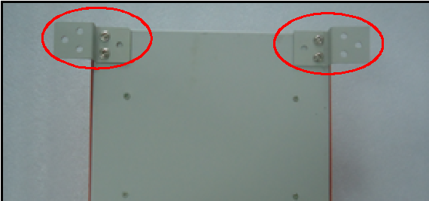
Place the controller in the location where it will be mounted. Verify that there is sufficient room to run wires and that there is sufficient room above and below the controller for air flow.
Step 4:Mark Holes
Use a pencil or pen to mark the eight (8) mounting hole locations on the mounting surface.
Step 5: Drill Holes
Remove the controller and drill 8 size able holes in the marked locations.
Step 6: Secure Controller
Place the controller on the surface and align the mounting holes with the drilled holes in step 5. Secure the controller in place using the mounting screws.

3.3 System Wiring

Note: In order to install security, we recommend a connection order.
Note: The JND - X series controller is a total of anode type control.

Warning: Ban the load end connection than controller surge power electrical equipment, in case of damage to the controller.

Warning: Need to move when using, make sure all wiring fixed well. Due to the empty string contact may lead to heat accumulation, serious and cause a fire.

Step 1: First closed the controller switch(before delivery is usually closed), open the terminal on the panel.

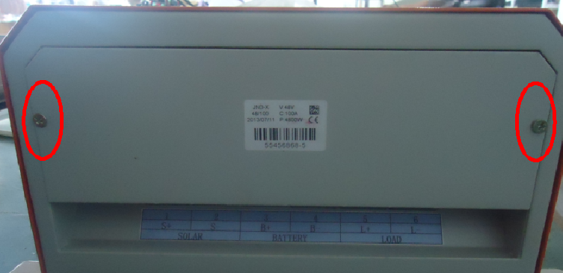
3-1
Step 2: Battery Wiring
Warning:If the battery positive and negative extreme and wires short circuit will cause the risk of fire or explosion. Please be careful operation.
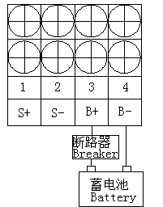
3-2. Battery connection
Before connecting the battery, ensure the normal state of the battery, in order to ensure the normal operation of the system.
According to figure 3-2, the installation process must not be connected to circuit breaker, after the connection is verified through to connect the circuit breaker.

Step 3:Solar Module Wiring

Warning: electric shock danger! Photovoltaic modules may produce high voltage, be careful to prevent wiring electric shock.

Please make sure that solar energy components in the system voltage or lower than the system voltage, shall not exceed the maximum input voltage range.

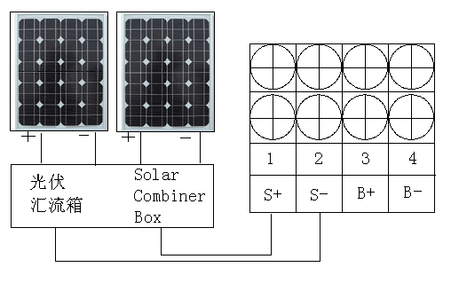
3-3 Solar modules connection
Step 4:Double-check the wiring in step1 through 4. confirm correct polarity at each connection. Verify that all six terminals are tightened.

Step 5:Confirm power-up
Closed switch controller, storage battery to power a controller, the controller starts up, LED blink on the controller battery, LCD will appear light and subtitles, observe whether it is right.
If the controller has not started, or the indicator light on the controller indicates errors, refer to chapter 5 remove fault.
IV. Operation

4.1 Battery Charging Status
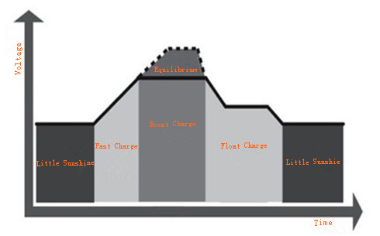
阳光
较弱时
阳光
较弱时
均衡
提升
·Fast Charging Gradation:

In fast charging gradation, solar controller will come into direct charge mode if voltage of battery cannot reach re-made full charge values.

·Boost Charging Gradation:

Solar controller will adjust battery voltage continuously to maintain boost charge setting point when battery voltage reached setting values.
It prevents battery from product gas and become too hot.
Battery boost charging time keeps about 120 minutes, and then solar controller will enter into float charge statues.
Solar controller will come into boost charge status while it identify battery isn’t in over-discharge and over-load status every time.

·Float Charging Gradation:

Solar controller will enter into float charging status after battery finished boost charge gradation.
All charging current will transform into heat and gas after battery is fully charged without more electrochemical reaction.
Solar controller with more little voltage and current to charging battery during float charge gradation.
Thus decrease temperature of battery and give out gas, then charging battery with little current.

Float charging is aimed at compensate electricity consumption from battery over-discharge and small load from system.
At the same time, keeps battery in full charged status.

Load can obtain electricity from battery continuously in float charging gradation.
Solar controller won’t keep in ready-made float charging values if load exceed solar charge current.
Solar controller will enter into fast charge gradation rather stay in float charge gradation if battery voltage values lower than float charge recovery values.
·Equilibrium Gradation
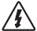
Warning: the explosion risk.Balanced openings lead-acid battery, can produce explosive gas.Battery must be well ventilated.


Note: equipment damage!
Equilibrium can increase the battery voltage to the dc load can damage sensitive level.Need to verify the permission of all the load to the system input voltage is greater than the battery charge balance set point.

Note: equipment damage!
Charging too much, too much gas evolution may damage the battery plate, and leads to the active material on the battery plate fall off.Equalizing charge is too high or too long may cause damage.Please check carefully to the specific requirements of the battery used in the system.

Some types of battery charged benefit from regular balanced, can stir up the electrolyte, the balance of battery voltage, complete the chemical reaction.Equalizing charge increase the battery voltage, make its voltage is higher than the standard, make the battery electrolyte gasification.
If a battery is detected over discharge, equalizing charge controller automatically control the charging, equalization charging time is 120 minutes.Equalization charging and ascension is not repeated in the process of a full, in order to avoid too much product gas or battery overheat.

4.2 Indicator light
· Charging indicator:
When the system connection is normal, and the system has a charging current when charging indicator light red Chang Liang, said the system charging circuit is normal.
· Battery indicator:
When battery over-voltage, green battery indicator light goes out; When the battery voltage, battery indicator light flashing green; When the battery is in normal state, green Chang Liang. See chapter 5 processing malfunction.

4.3 controller parameters view and set operation

LCD initial interface introduced
For users after 3.3 this connection and power operation, general automatically entered into the following interface (default during the day, as shown in figure 4.3.1).
“Battery” on behalf of the display Battery voltage at this time, digital is the Battery voltage readings；
On behalf of the day, solar panels in the power generation
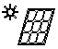
state, if removed panels connection, or into the night, the
icon out, the moon icon appears.

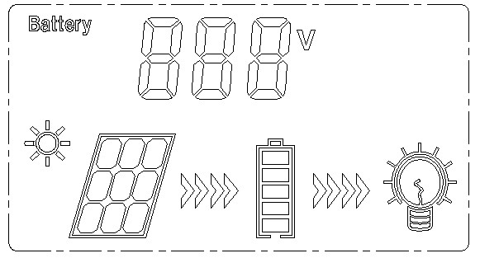

4.3.1
Tworepresent the charging and discharging, for charging, have the current will show effect, when there is no current or current is very small, the label will disappear;For discharge, when the battery is in a state of undervoltage, flashing the overall effect, when the battery is in good state, according to static effect, marking can pick up the load, after loading,if there are current,will display effect.
Battery, in the middle of the five bars represent the current battery power

Load, when connected to the load, there will be lighting effects
·Browse other parameters introduced
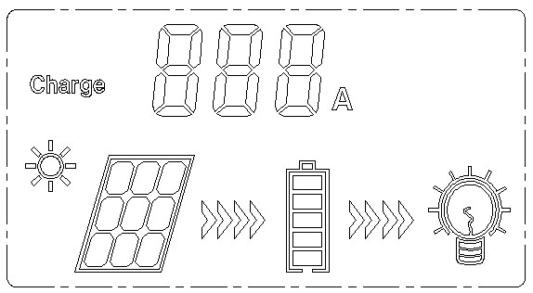
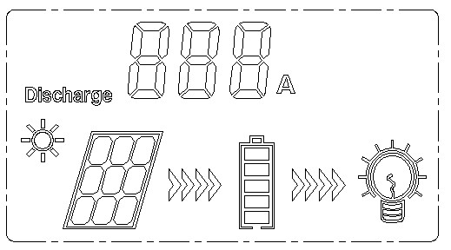
Users click to view the charging current, the page is shown in figure 4.3.2,“Charge”on behalf of the displayed charging current,behind the numbers is the charging current readings;in the figure 4.3.2 interface, users click will return to the interface of figure 4.3.1,click to view the discharge current，the page is shown in figure 4.3.3，“Discharge”on behalf of the discharge current,behind the Numbers is the discharge current readings.

4.3.2 4.3.3
The above three pages, collectively known as browse pages, when a minute don't operating controller buttons, LCD backlight will automatically go out.after pressing any key will once again lit backlight and continuously for one minute.

·Parameter Settings:
Press Enter to controller with parameter is set into the interface, as shown in figure 4.3.4,“Float” represent this time can be set to float charging voltage value, the user can press or key numerical,each time you press the increase or decrease 1v,set up finished,the user can press the ESC key to exit to browse the first page, also can continue to press the Enter key to Enter 4.3.5 as shown in the page.
As shown in figure 4.3.5, “LVD”represent this time can be set up under-voltage protection voltage numerical, the user can press or numerical, each time you press the increase or decrease 1v,set up finished, the user can press the ESC key to exit to browse the first page, also can continue to press the Enter key to Enter 4.3.6 is shown in the page.
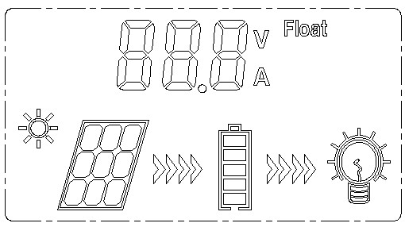
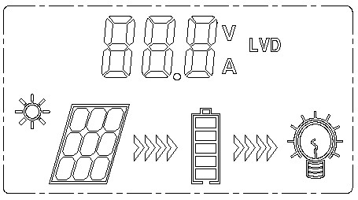

4.3.4 4.3.5
As shown in figure 4.3.6, "OVD" represent can be set up at this time of over-voltage protection numerical, the user can press the key or key numerical, each time you press the increase or decrease 1 v, set up finished,, the user can press the ESC key to exit to scan the first page.
The above three pages are collectively referred to as Settings, LCD backlight will not automatically, please press the ESC key to exit the users to browse the first page, a minute is not operating controller buttons, LCD backlight automatically extinguished.

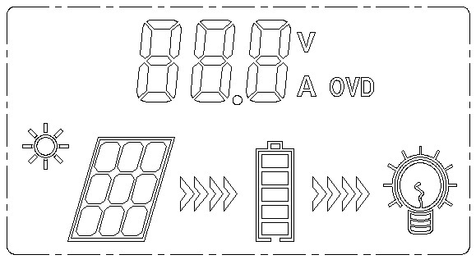

4.3.6

V 。Communication accessories
Users according to the demand of choose and buy the following parts
5.1 RS232 USB cable
5.2 Software installation CD
5.3 Software installation instructions

VI.Protection, Troubleshooting and Maintenance

6.1 The controller have great protections as below:
·PV array short circuit:
PV array input short circuit, when it solved, the controller will continue to charge the battery automatic.
·Reverse connection of PV modules:
When reverse connection of PV modules, the controller will not damaged. After you modify the wrong connection, the controller will continues to work safety.
·Reverse connection of battery:
When reverse connection of battery, the controller will not damaged. After you modify the wrong connection, the controller will continues to work safety.
·Sensor off:
When the current-sensor-wire off, it will affect the current display, but it does not affect the normal charging and discharging of the system.
·High voltage surges:
This controller have great protection for smaller energy with high voltage surges. At lighting frequently areas, we suggest to install external arrester for the controller.

6.2 Troubleshooting
If the controller meet these problems as below, please solve them according to the suggestion.

Troubleshooting 6-1
Problem | Main reason | Workaround
When there is sun on the PV modules, and the red charging indicator don’t light. | Battery is full charging or the PV array connection is open | First please check that if the battery is full charging. The indicator will not light if the battery is full charging. Then please check if the internal connection of PV modules and battery is correct and reliable.
The green indicator is not light | The battery is under voltage | When the battery is back to normal, the green light will auto recovery.
The green indicator flash | The battery is under voltage | When the battery is fully charged, the green light will auto recovery.

Warning: If all of the LED and LCD don’t indicate, please check if the switch of the controller on “ON” side.
Warning: If the connection is right and the charging indicator don’t light, please check if the output voltage of the PV module is high than battery voltage.

6.3 The Maintenance of the system
In order to maintain the best long-term performance, we recommend the following checks twice a year.
• Make sure that the controller is securely mounted in a clean, dry environment.
• Make sure that the air flow around the controller will not be blocked. Clear any dirt or debris that on the radiator.
• Check all of the exposed wires are well or damaged. Because of the sun, and other objects around the friction, such as dry rot, insect or rodent damage the insulation. If necessary, repair or replace wires.
• According to suggestion, please tighten all electrical connection terminal screws.
• Check the grounding of all components, verify that all ground wires are securely and properly grounded.
• Check all terminals, see if there is corrosion, insulation damage, heat or burning / discolored sign, tighten the terminal screws to the recommended torque.
• Check for dirt, insects and nesting corrosion, as required cleanup.
• If the arrester has expired, the timely replacement of failed arrester to prevent causing the controller to other devices or users lightning damage.


Warning: Risk of electric shock!!!
Please make sure that all of the power is off before you do these checks.

VII.Warranty
The charge controller is warranted to be free from defects for a period of TWO (2) years from the date of shipment to the original end user. We will, at its option, repair or replace any such defective products.
This warranty does not apply under the following conditions:
1. Damage by accident, negligence, abuse or improper use.
2. PV or load current exceeding the rating of product.
3. Unauthorized product modification attempted repair.
4. Damage occurring during shipment.
5. Damage results from acts of nature such as lightning, weather extremes.
6. Irreclaimable mechanical damage.

VIII.Detailed technical parameters

Electrical parameter 8-1
Battery voltage parameters（Temperature：25℃） 8-2
Electrical parameter | parameter
rated system voltage | DC  240V | DC  220V | DC  216V | DC  192V | DC  120V | DC  110V | DC  96V
Rated charge current | 50A | 50A | 50A | 50A | 50A | 50A | 50A
The maximum allowable voltage | DC  320V | DC  293V | DC  288V | DC  256V | DC  160V | DC  147V | DC  128V
Max input voltage | DC  450V | DC  430V | DC  430V | DC  400V | DC  250V | DC  230V | DC  200V
Min input voltage | DC  300V | DC  275V | DC  270V | DC  240V | DC  150V | DC  138V | DC  120V
Max input power | 12000W | 11000W | 10800W | 9600W | 6000W | 5500W | 4800W
Static loss | <0.2A
Charge loop drop | ≤0.5V
Discharge circuit of pressure drop | ≤0.3V
controls parameter
Over voltage switching off | 320V | 294V | 288V | 256V | 160V | 147V | 128V
Over voltage Recover | 300V | 275V | 270V | 240V | 150V | 138V | 120V
Average voltage | 294V | 270V | 265V | 235V | 147V | 135V | 118V
Boost voltage | 290V | 266V | 261V | 232V | 145V | 133V | 116V
Float voltage | 276V | 253V | 248V | 221V | 138V | 127V | 110V
undervoltage recovery | 250V | 229V | 225V | 200V | 125V | 115V | 100V
undervoltage | 216V | 198V | 194V | 173V | 108V | 99V | 87V
Under voltage disconnect | ——
Duration of equilibrium | 2 hours
Note: The table 8-2 can be set up on behalf of this keypad and LCD Settings, all parameters can be set through the communications software
Environmental parameter 8-3
Environmental parameter | parameter
Work temperature | -35℃- +55℃
Store Temperature | -35℃- +80℃
Temperature Range | 10%-90%No condensation
Protection level | IP30
Using altitude | ≤3000m
Mechanical parameter 8-4
Dimension | 355*273*142(mm)
Hole Size | 295mm x 353mm
Hole size | Φ7
Terminal | 24mm²
Net weight | 7.1kg
Dimension | 355*273*142(mm)
Dimension (mm)
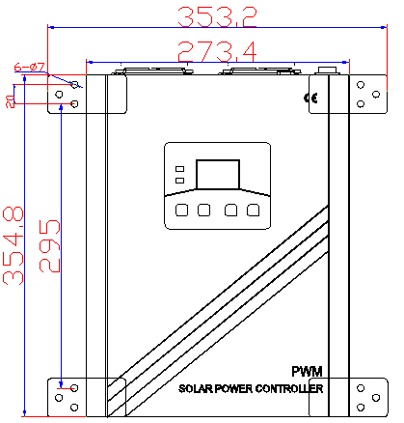

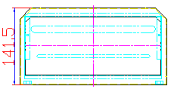

This manual final interpretation owned by our company, if there is any change, without prior notice!

