250w mono solar panel specifications

Product Name | Solar module | Model |  |  | CY-TD250W
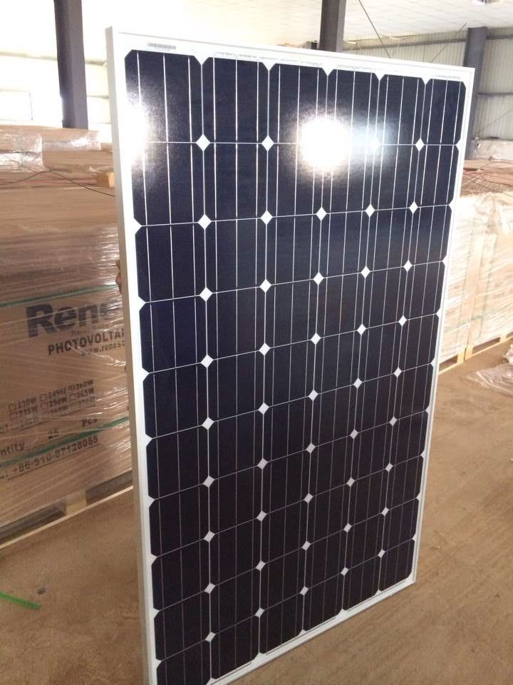 |  | Peak Power (Pm) (W) |  |  | 250W
 |  | Maximum Power Voltage Vm (V) |  |  | 24V
 |  | Maximum Power Current Im (A) |  |  | 8.33A
 |  | Open Cicuit Voltage Voc (V) |  |  | 28.32V
 |  | Short Circuit Current Isc (A) |  |  | 9.00A
 |  | Maximum System Voltage (V) |  |  | 1000V
 |  | Cells Type （Mono/Poly） |  |  | MONO
 |  | No. Of Cells and Connection（PCS） |  |  | 48PCS (6*8)
 |  | Cells Dimension (mm) |  |  | 156x156
 |  | Pm Temperature Coefficient（%/℃） |  |  | -0.45%/℃
 |  | Voc Temperature Coefficient（%/℃） |  |  | -0.35%/℃
Tolerance （%） | ±3% | IscTemperature Coefficient （%/℃） |  |  | +0.05%/℃
Dimension (mm) | 1320*992*35mm | Standard Test Condition(STC) |  |  | Am1.5 25℃ 1000W/㎡
Net Weight (Kg) | 16Kg | WorkingTemperature range(℃) |  |  | -40℃～90℃
Gross weight | 35Kg | Packing quantity (pcs) |  |  | 25pcs/ big carton box with pallet or 2pcs/carton
Product component | Tempered Glasses + EVA + Solar Cells + EVA + TPT + Aluminum Frame + International Standard Junction Box
Glasses | low carbon Tempered Glasses |  | Frame Type | 35x35mm Aluminum Frame
Junction box | International Standard Junction Box
Certificate | TUV : CE : ROHS ： IEC61215 : CGC
Warranty | 5 years for full product power,10 years for 90% product power,25 years for 80% product power.

